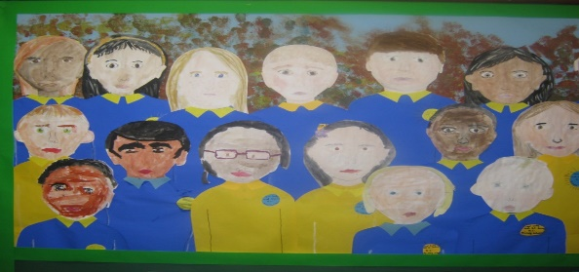

Online Safety Code of Conduct for Pupils
I agree to follow these rules when using the Internet:
- I will not share my username, password or personal information with anyone else
- I will make sure that computing communication with other users is responsible, polite and sensible
- I will not look for, save or send anything that could be upsetting or cause offence. If I accidentally find anything like this I will tell a teacher immediately
- I will only upload materials which are free from copyright and suitable for school use
- I will not deliberately misuse or deface other users’ work on the school network
- I know that my use of the Internet is monitored and further action may be taken if a member of school staff is concerned about my safety
- I will be responsible for my behaviour when using the Internet because I know that these rules are designed to keep me safe
- I will not bring a mobile phone to school
- I understand and agree to the rules above and am aware there may be sanctions if I do not follow them

Accessing remote learning via Teams
In the event of school closures / pupils having to self-isolate due to Covid 19, teachers will provide learning/deliver lessons online. These may be classroom-based (in the event of pupils self-isolating) or, in the event of school closure, hosted by the teacher in a safe, secure and controlled online environment using the video conferencing facility in Microsoft Teams.
Guidelines for online learning: Pupils
If you are self-isolating then you will access the classroom-based lessons using Teams.
If a teacher enables video then their head and shoulders are visible, as are your head and shoulders. You should behave online as you would behave in class.
What does this mean when you are taking part in a Teams lesson when NOT in school?
- You should not seek to disrupt or distract either your own learning or those of others with inappropriate use of the digital tools.
- If you feel uncomfortable or feel that anything inappropriate has happened in the virtual environment you should contact Mr O’Brien, Headteacher via ourladyadmin@olsa.org.uk
- You should turn up for a Teams lesson on time and with the appropriate equipment for that subject.
- You should end the Teams lesson when the teacher tells you it has finished.
- You should not have a mobile phone with you when the lesson is taking place.
- You should not take part in the Teams lesson in your bedroom: use another room/area in the house.
- You must not take photos or screen shots at any point in the lesson.
- All work uploaded to Teams should be your own.
- You should stay focused and quiet when involved in a Teams lesson.
- You should dress as you would for a non-uniform day at Our Lady & St’ Anne’s.
- You should know how to communicate with the teacher, and with other students, during the Teams lesson, and you should follow these rules throughout.
- You should ask permission to leave your Teams lesson (for example, to go to the toilet); this should be done using the ‘raise your hand’ function.
- You should not have drinks (other than water) or eat any food during the lesson.

