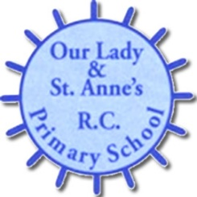
SPONSORSHIP FORM for Superhero Fun Run on Friday 7th September 2018

My name is ____________________ and I am participating in the Superhero Fancy Dress Fun Run to raise money for the Children’s Cancer Ward at The Great North Children’s Hospital.

Name | Amount | Paid

TOTAL –

Please return the completed form with collected donations to the school office by Friday 14th September 2018.

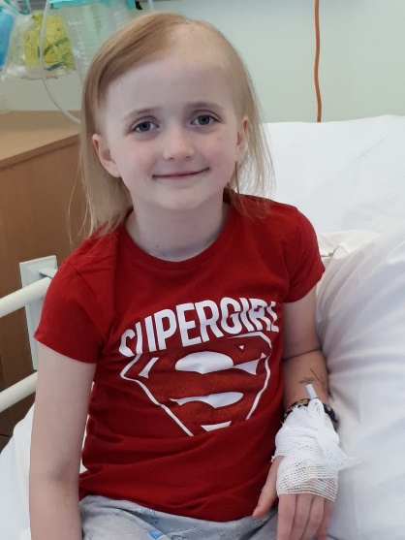

SUPERHERO FANCY DRESS FUN RUN!!

We will be holding a whole school fancy dress fun run on Friday 7th September. We are running in support of Mrs Clennell’s daughter Bella and to raise money for the Children’s Cancer Ward based at the The Great North Children’s Hospital.

In May 2018 Bella was diagnosed with a Germinoma, a form of brain cancer, after having a number of health difficulties for some time.

Bella really is a real life Wonder Woman, so please support us by being a super hero for the day. Come to school in fancy dress and find as many people as you can to sponsor you to take part in the run.

Children will be bringing home a sponsorship form today, which can be returned to the school office after the holidays.

The money raised will go towards providing toys, materials and services that add value and comfort to the children and families spending time in hospital for cancer treatment.

£5 pays for a soft toy for a child to cuddle during radiotherapy treatment.
£22 pays for a Chemo duck toy to help a child use play to understand their treatment.
£30 pays for a gift to celebrate the end of a child’s treatment
£100 keeps boredom at bay with the lastest DVD’s and games
£730 pays for a good sleep for parents in a new bed
£1000 pays for festive fun for a children’s Christmas Party

PLEASE SUPPORT US IN MAKING THE DAY EXTRA SPECIAL!!!

