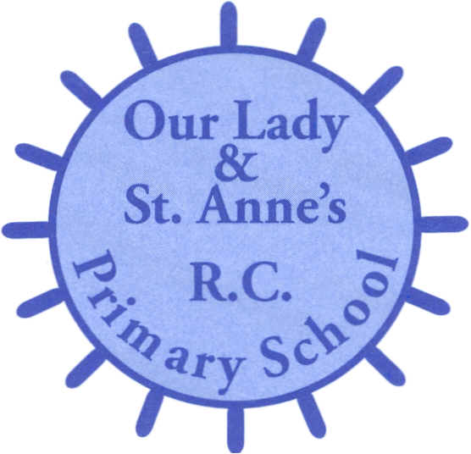

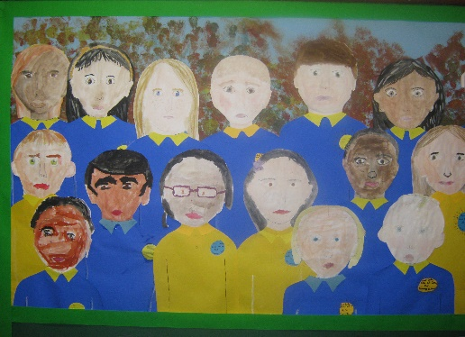

Information for Parents

Special Educational Needs

Who can I talk to about SEN at Our Lady and St. Anne’s Primary School?

The child’s class teacher would be the first person you could go to if you are concerned about your child’s learning.

Other people who would be able to help with any SEN issues are:

Head Teacher: Mr M. O’Brien

SENCO: Miss M Limer

Lead SENTA: Ms Donnelly

SENTA: Ms Kaur

Contact details

Email: [ourladyadmin@olsa.org.uk](mailto:ourladyadmin@olsa.org.uk)

Phone Number: 232 5496

SEN Information Document

This report can be found on the school website. It outlines the provision we make for all pupils with SEN and within the four broad areas of need – communication and interaction (CI); cognition and learning (CL); social, emotional and mental health difficulties (SEMH); sensory and/or physical (SPh).

Special Educational Code of Practice

At Our Lady and St. Anne’s School, every child is equal, valued and unique. We aim to provide an environment where pupils feel safe and can flourish and provide an education that enables all pupils to achieve their best.

We follow the graduated approach of assess, plan, do and review as outlined in the Code of Practice and every teacher is responsible for ‘adapting teaching to respond to the strengths and needs of all pupils’.

What are Special Educational Needs?

Special Educational Needs (SEN) are additional needs or difficulties with learning, which lead to pupils needing extra help with their work. They may get in-class or out-of-class, individual or group support or it is maybe that their work has been prepared in a different way.

What is the Special Educational Needs school list?

This is a list of children who are currently having extra support in school or needs that all staff must be aware of.

There are two stages of this:

**SEN Support.** Children receive extra help from one of the Special Educational Needs Teaching Assistants (SENTAs) and may receive programmes of work/advice from other professionals.

**Education Health Care Plan (EHC plan).** Children with an EHCP need a higher level of support and school will receive advice from external agencies.

If my child is on the Special Needs List, will he/she ever come off?

The length of time on the list varies. If a child receives extra support and overcomes their difficulties then they will only be on for a short time. All children have individual targets, to help them with their learning, that are reviewed termly. Targets are discussed at parents’ evenings and at reviews throughout the year.

Who is involved from outside school?

Some experts may be asked to assess your child’s needs if they continue to have difficulties.

* The Education Psychologist (EP) may do more detailed tests of a child’s ability and development to help everyone to better understand the needs of the child. Our EP is called Nia Patton. Parents are involved in this process.
* Special Educational Needs Teaching and Support Service (SENTASS) may give school advice and ideas as to help children make progress.

Our Dyslexia Teacher for SENTASS is Trish Moore.

Our Speech and Language Teacher for SENTASS is Tracy Hawdon.

* The Speech and Language Team (SALT) carry out assessments and provide teachers and parents advice and interventions for the child where necessary.