Learning Project WEEK 7 - Celebrations
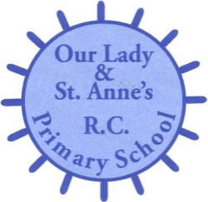
Age Range: ​EYFS
Weekly Maths Tasks (Aim to do 1 per day) | Weekly Reading Tasks (Aim to do 1 per day)
- Watch a Numberblocks clip each day at: BBC or ​ CBeebie​s. Use this guide ​ her​e​ to give you ideas on what to do with your children whilst watching an episode.  - Play this gam​e to practise counting,​ ordering and matching numbers to 10.  - Practise counting up to 20. This can be done through playing hide and seek, singing number songs, chanting, board games etc.  - Listen to a number song from the  CBeebies ​ website. After listening to them, watch again and sing along if you can. Talk about the maths you can see in the video clip.  - Make a selection of birthday cards with numerals on the front. Can your child count out birthday candles (if you have them available) or objects to match the amount? Can they order the numerals from the smallest amount to the largest?  - Talk about different celebrations. How many different ones can the children come up with. | - Read a variety of books at home. Favourites can be repeated.  - Visit Oxford Owl for free eBooks Complete the linked Play activities for each book.  - Look for those books which have celebrations in.  - Use the Small Tal​k ​ website for ideas on supporting your child’s Communication and Language development.
Weekly Phonics Tasks (Aim to do 1 per day) | Weekly Writing Tasks (Aim to do 1 per day)

- Sing Nursery Rhymes and songs together. Add in actions and change the words. Can children think of different rhyming words to add in? Repeat old favourites and learn new rhymes. You can find an A-Z of Nursery Rhyme​s.​  - Daily phonics - Practice the sounds your child is working on and blend words. This can be oral blending (e.g. spoken out loud c-a-t) or written if appropriate. Interactive games.​  - Watch a video of a fireworks display. Can your child explore using instruments (if available) or household objects e.g.  pots and pans to make their own imitation of firework sounds. | - Create a card for a celebration of your choice. Can your child use their phonics knowledge to write a message for the person they would like to give it to?  - Ask your child to draw a picture of a celebration they have taken part in. Encourage them to use their phonics knowledge to write about their memory of that day.
Learning Project - to be done throughout the week
This project this week aims to provide opportunities for your child to learn more about celebrations. Learning may focus and different types of celebrations that take place and who may celebrate them. It could look at how people celebrate different events differently in other parts of the world.
- Family Photographs-
  - Look over a selection of photographs of family celebrations and discuss with your child: what the celebration was about, who attended, what you did to celebrate, when it took place, whether it is an event that happens each year. Can your child remember the event taking place? What do they remember of it?

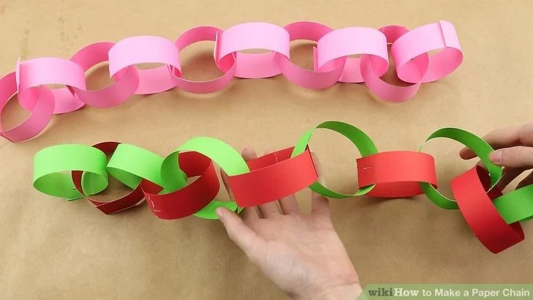
- Plan a family celebration-
  - Decide on a family celebration for the week. This could be a family indoor picnic, meal, dance etc. Ask your child to write invitations to family members to the party.
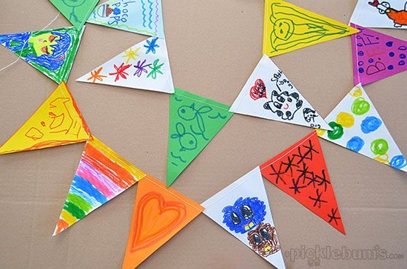
○ Create homemade decorations using coloured paper (If you do not have coloured paper at home, you could use old newspaper or wrapping paper) You could make paper chains or bunting
○ Plan a menu for the party and make the food together.

- Discover religious celebrations-
  - Watch the Let’s Celebrate videos on cbeebies – iplayer/youtube. ​Discuss the celebrations with​ your child. Which of the events did they take part in? which is their favourite and why?

○ Watch the Let’s Celebrate video collection for Eid-al-Fitr​ . ​ Discuss the celebrations with your child. Did they celebrate Eid-al-Fitr? How did they celebrate? Are there any similarities and differences between the celebrations they saw in the Easter videos?

○ Look through the range of video​s ​ available on Cbeebies and watch together. Discuss who celebrates the event and any similarities and differences with celebrations your child has taken part in.

- Birthdays-​
○ Talk to your child about when they were born. Look at photographs of the day they were born, if you have them available. Do they know the date of their birthday? Support your child to create an all about me folding book (as pictured) with their birth date, current age and anything else they think is important for people to know about them.
Additional learning resources parents may wish to engage with
Classroom Secrets Learning Packs -​ These packs are split into different year groups and​ include activities linked to reading, writing, maths and practical ideas you can do around the home.
Twinkl ​ - to access these resources click on the link and sign up using your own email​ address and creating your own password. Use the offer code UKTWINKLHELPS.

