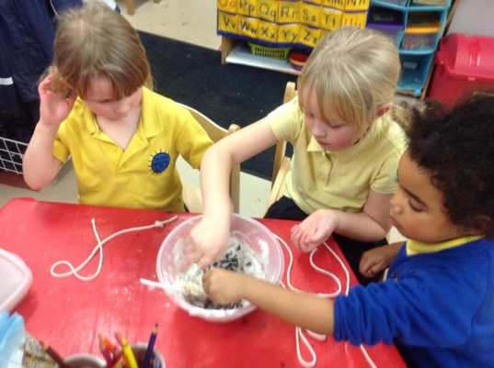
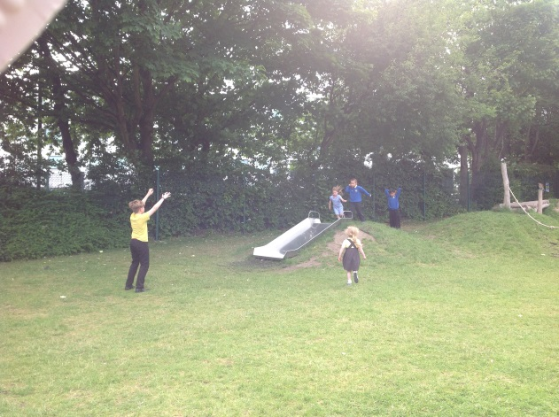
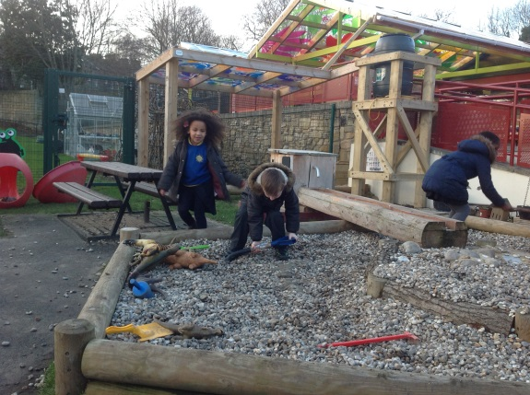
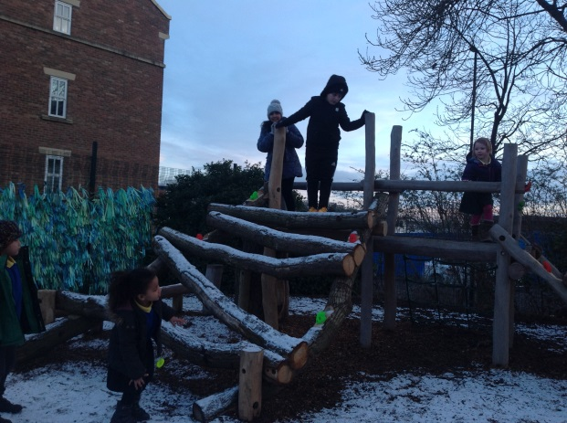
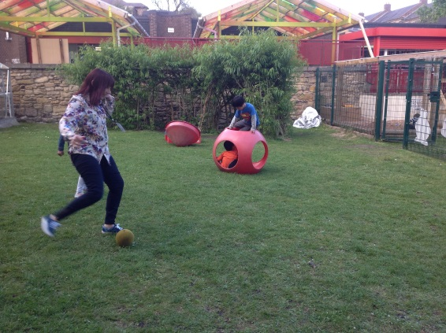
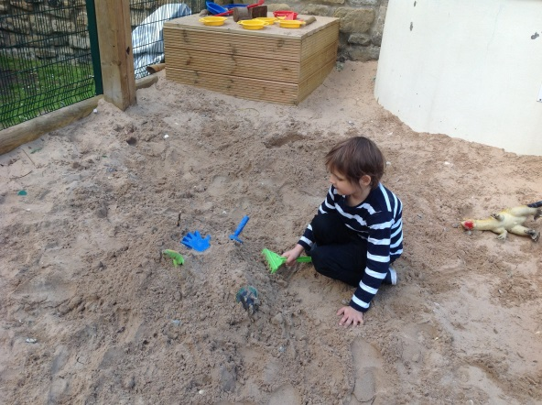
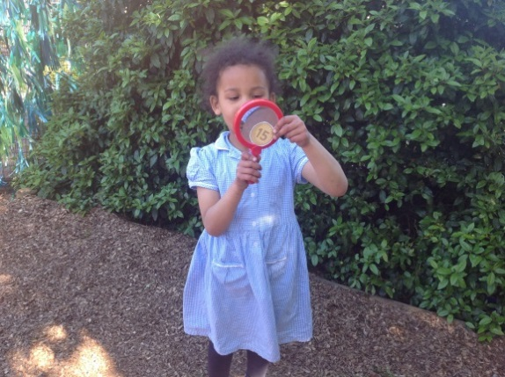
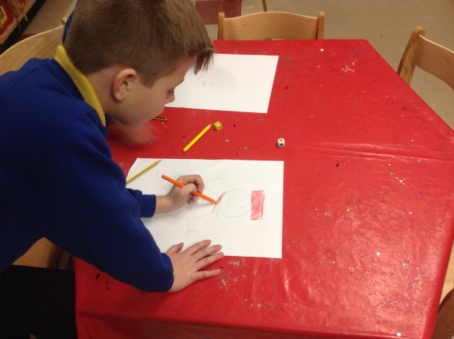
Welcome to
Out of School Club

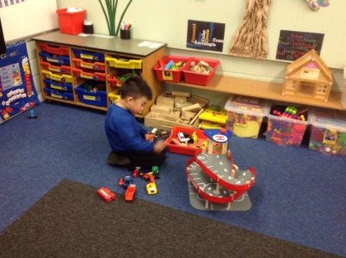
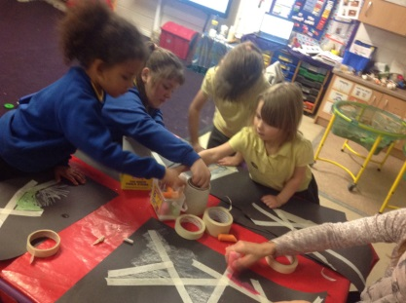
Mrs Hall-Murray
Playworker
Miss Higgins
Playworker
Miss Elliott
Manager
Miss Mackell
Playworker
Miss McAnespie
Playworker
Meet The Staff
Contact Information
OLSA Out of School Club
Summerhill Terrace
Newcastle
NE4 6EB

Club mobile number: 07437768427(Please leave a voice message if there is no reply.)
Ofsted Registration No: 108510
Correspondence Address:
As Above
Tel (Manager): 0191 2325496

Club Staff
School Business Manager: Mrs. Z. Clennell
Manager: Miss S. Elliott
Playworkers: Miss D. Higgins
Miss E. Mackell
Mrs. J. Hall-Murray
Miss. G. McAnespie

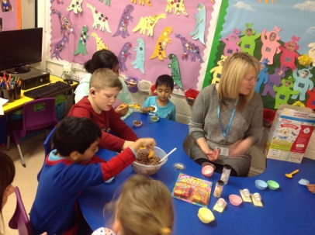
About the club
OLSA Out of School Club is registered with Ofsted (Registration No 108510), and is based in Our Lady & St Anne’s RC Primary School. The club is open from 3.15pm until 5.30pm weekdays, during term time.
Aims
At OLSA Out of School Club we aim to provide a safe and secure and relaxed environment, offering a range of activities to reflect the interests of the children in our care.
What we offer
Our Club follows the Playwork Principles, so the children are free to choose activities and resources as they wish. There will always be a selection of activities and resources available, including dressing up, home corner, craft, board games, construction, computer games, physical play, cookery, and reading. In addition other resources are available for the children to select from our resources library.
What we provide
The food we provide at the Club is not intended as a substitute for a main evening meal. We provide healthy snacks, including fresh fruit and vegetables. We promote independence, by encouraging the children to prepare their own snacks, and to clear away after themselves. We use fresh ingredients and follow statutory guidelines. Fresh drinking water is available at all times. We meet individual dietary requirements and parental preferences wherever possible. We recognise the importance of healthy nutrition for children delivered in a calm, friendly setting. We allow children to decide when they are ready to eat, but request that food be consumed whilst sitting at the snack table.
Staffing
Our Club is staffed by a manager, Miss Elliott, and four playworkers. In addition we have volunteer staff. Our aim is to provide a smooth transition between school and club.
All of our staff have significant experience of working with children and undertake professional development training. All staff members are DBS checked. We maintain a staff/child ratio of 1:8 for children under the age of eight, and a ratio of 1:10 for children over the age of 8.
If you have a query or concern at any time, please speak to a member of staff at the club when you collect your child. If you prefer to arrange a more convenient time for a meeting please contact the manager (contact details are at the back of this Handbook).
Policies and procedures
The Club has clearly defined policies and procedures. Key points of the main policies are included in this Handbook. Copies of the full policies are kept at the Club and are available for parents to consult at all times.

Terms and conditions
Admission
Admission to the club is organised by the School Business Manager and club manager and we use a waiting list system when the need arises. The waiting list will be operated on a first come-first served basis, with the exception of siblings who will have priority for the same days as a sibling already attending. See our Admission and Fees Policy for more details.
We require a completed set of registration forms for your child before they can attend the club. This information will be treated as confidential and will be stored appropriately.
Re-enrolment for September is required at the end of the summer term. We cannot keep a place open for your child unless you complete a new registration form.
Payment of fees
Please see our Admissions and Fees Policy for current fees. Fees are payable in advance by bank transfer or childcare vouchers. We accept Kiddivouchers. (Please contact the School Business Manager if you currently receive vouchers from an alternative provider)
The price per session per child applies to all children. This is payable for all booked sessions unless prior notice is given or your child is ill from school. Please ensure that fees are paid promptly. Non-payment for more than one month may result in your place being terminated. If you are having difficulty paying fees, please speak in confidence to the Club Manager.
Changes to days and cancelling your place
You must give us one month’s notice of termination and seven days’ notice for any changes in attendance pattern. If you need to change the days that your child attends, please contact the Club Manager. We try to accommodate such changes wherever possible.
Temporary changes
Please remember that we need to know if your child will not be attending the Club for any reason. If your child doesn’t attend a booked session, we will have to treat them as a ‘missing child’ unless you have notified us of their absence.
If you know in advance of any days when your child will not be attending during the following week, please try to let the Manager know by THURSDAY at the latest. In cases of illness or emergency when notice cannot be given, please call as soon as you can. Contact details can be found at the end of this Handbook.
Induction
During your child’s first session, time will be set aside for an induction. The induction will include running through Club's rules and routines (including meal times, collection, children's meetings), and introducing your child the staff and other children.
Another child will usually be allocated to act as your child's buddy for the first few sessions.
See our Child Induction Policy for more details.

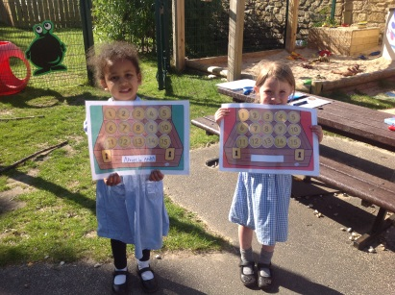

Arrivals and departures

Our staff collect children from their class and escort them to the Club. A register is taken when children arrive in our care, and you must sign out your child each day when you collect them.
We expect that your child will normally be collected by the people you have named on the registration form. If you need a different person to collect your child on a particular day, you must notify us in advance. We will not release your child into the care of a person unknown to us without your authorisation.
See our Arrivals and Departures Policy for more details.
The club finishes at 5.30pm (unless other arrangements have been made with the School Business Manager); if you are delayed for any reason please telephone the Club to let us know. A late payment fee of £3.00 will be charged if you collect your child after the Club has closed.
If your child remains uncollected after 6.00pm [30 minutes after your club closes] and you have not warned us that you will be delayed, and we have been unable to reach you or any of your emergency contacts, we will follow our Uncollected Children Policy and contact the Social Care team and the Police.
Child protection
We are committed to building a ‘culture of safety’ in which the children in our care are protected from abuse and harm. Any suspicion of abuse is promptly and appropriately responded to. We comply with local and national child protection procedures and ensure that all staff are appropriately trained. For more details see our Safeguarding Policy.
Equal opportunities
Our Club provides a safe and caring environment, free from discrimination, for everyone in our community including children with additional needs.
- We respect the different racial origins, religions, cultures and languages in a multi-ethnic society so that each child is valued as an individual without racial or gender stereotyping.
- We will challenge inappropriate attitudes and practices
- We will not tolerate any form of racial harassment.
Special needs
We make every effort to accommodate and welcome any child with special needs. We will work in liaison with parents or carers and relevant professionals to fully understand your child’s specific requirements. We will endeavour to accommodate all children of all abilities, whilst working within the Club’s limitations. Each case will be considered individually and risk-assessed to ensure everyone’s safety.
Our staff training programme includes specific elements relating to children with special needs.
For more details on equal opportunities and special needs, see our Equalities Policy.

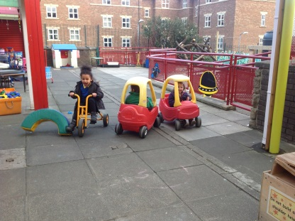
General Information
Behaviour (children)
Children and staff have created rules for acceptable behaviour whilst at the Club. We have a clear Behaviour Management Policy. If you would like a copy, please see School Business Manager.
The Club promotes an atmosphere of care, consideration and respect for everyone attending: children, staff and visitors.
We encourage appropriate behaviour through: praise for good behaviour; emphasis on co-operative play and sharing; talking to children with the courtesy that we expect from them and engaging children in activities
The Club has procedures for dealing with unacceptable behaviour. We recognise that poor behaviour can occur from time to time for reasons that are not always evident, or as a result of special needs. We will try to be flexible in order to accommodate such cases.
However, if your child is violent, or if their behaviour poses an immediate danger to themselves or others, we will require you to collect them from the Club immediately. In exceptional circumstances, and only when all other attempts at behaviour management have failed, we reserve the right to permanently exclude a child from the Club. See our Suspensions and Exclusions Policy for full details.
Behaviour (adults)
We will not tolerate from any person, whether a parent, carer or visitor: bullying; aggressive, confrontational or threatening behaviour; or behaviour intended to result in conflict. Our Club is a place of safety and security for the children who attend and the staff who work here, and we reserve the right to ban anyone exhibiting inappropriate behaviour from our premises. See our Aggressive Behaviour Policy for more details.
Illness
We are unable to care for children who are unwell. If your child becomes unwell whilst at the Club we will contact you and ask you to make arrangements for them to be collected.
Please inform the Manager of any infectious illness your child contracts. If your child has had sickness or diarrhoea please do not send him or her to the Club for 48 hours after the illness has ceased. See our Illness and Accidents Policy for more details.
Accidents and first aid
Every precaution is taken to ensure the safety of the children at all times, and the Club is fully insured. Our staff are trained in first aid and a first aid kit is kept on the premises. If your child has an accident whilst in our care, you will be informed when you collect your child. For full details see our Illness and Accidents Policy.
Medication
Please let the Club Manager know if your child is taking prescribed medicine. If your child needs to take medicine whilst at the Club you will need to complete a Permission to administer medication form in advance. See our Administering Medication Policy for more details.

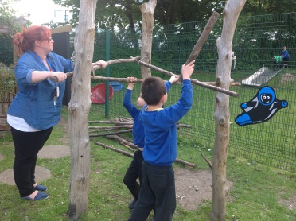

Complaints procedure
If you have any queries, comments or need to discuss any matters concerning your child, please feel free to speak your child’s key person, the Manager, or any other member of staff.
Verbal complaints will be brought to the next staff meeting for discussion and action.
All written complaints will be acknowledged within five working days of receipt and a full written response will be given within 28 days.
A full copy of our Complaints Policy is available on request.

Pledge to Parents
We value our relationship with parents/carers and are committed to working in partnership with you to provide top quality play and care for your children. We will:
- Welcome you at all times to discuss our work, have a chat or take part in our activities.
- Keep you informed of opening times, fees and charges, programmes of activities, menus, and procedures.
- Be consistent and reliable to enable you to plan with confidence and peace of mind.
- Share and discuss your child's achievements, experiences, progress, and friendships.
- Be available to discuss decisions about running the club.
- Ask your permission for outings and special events.
- Listen to your views and concerns to ensure that we continue to meet your needs.
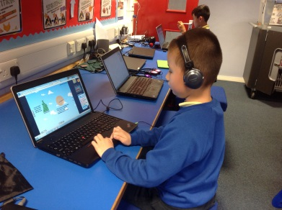
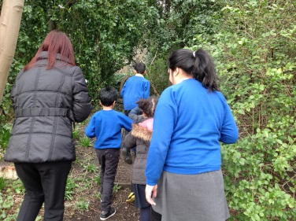
 | Snack and drink
Monday | - Toast – with butter and jam, chocolate spread, peanut butter or lemon curd.  - Water, blackcurrant or orange juice.
Tuesday | - Crackers – with butter and cheese.  - Water, blackcurrant or orange juice.
Wednesday | - Sandwich – jam, ham, cheese, peanut butter, tuna or chocolate spread.  - Water, blackcurrant or orange juice.
Thursday | - Bread sticks with a selection of dips.  - Water, blackcurrant or orange juice.
Friday | - Cheese toastie or toast with spreads.  - Water, blackcurrant or orange juice.
 | 3:15-3:45 | 3:45-4:15 | 4:15-5:15
Monday | Snack time | Outside play | Mosaic eggs
Tuesday | Snack time | Outside play  (free play if wet) | Pasta necklaces
Wednesday | Snack time | Outside play  (free play if wet) | Easter pop up cards
Thursday | Snack time | Outside play  (free play if wet) | Easter baskets
Friday | Snack time | Outside play/Hall time  Cooking: Fudge
OLSA Out of School Club: Example timetable
OLSA Out of School Club: Weekly menu

Out of School Club: Admissions and Fees Policy
OLSA Out of School Club is registered with Ofsted; our registration number is 18510. We provide care for up to 16 children between the ages of 3 and 11, serving the children of Our Lady & St Anne’s RC primary School.
Places are offered on a first-come first-served basis. When all places have been filled a waiting list will be established, with the following order of priority:
- Siblings of children already attending the club
- Those requiring the greatest number of sessions/hours per week

Registration
When an enquiry regarding places is made, parents or carers will be given all the relevant Club information, including:
- Information regarding availability of places
- Details of the Admissions and Fees policy
- Registration form, parent contract, booking form
If a place is available, the child will be offered a place. The child will be able to attend the Club as soon as the completed forms are received. If no places are available the parent will be informed and the child’s name added to the waiting list. As soon as suitable places become available parents will be informed.

Booking procedure
Parents must complete the necessary paperwork, ie contract, registration and booking forms, before their children can attend the club.
- Permanent place: Once booked, if a child does not attend (unless absent from school that day due to illness), you will still be charged for this place. If you wish to cancel the place altogether, one month’s notice in writing is required.
- Temporary booking: We will accept temporary or occasional bookings as long as there are places available. If a temporary place has been booked and is no longer required, the club must be given 48 hours notice. If notice is not given, the place will still be charged for.

Fee structure
Fees are charged at 3:15-4:30pm: £3. 3:15-5:30pm: £5.
- Fees are payable in advance.
- Fees can be paid via our online portal.
- There is a charge of £3 for late collection, which will be added to the next invoice.
- Fees are charged for booked sessions whether the child attends or not.
- We offer a 20% discount for siblings

Payment of fees
Fees are reviewed annually. The Club will consider requests for variation to payment terms on an individual basis. Anyone making these requests should contact the School Business Manager at the earliest opportunity. Any queries regarding fees should be directed to the School Business Manager.
If fees are not paid, the Club will write to the parent or carer, requesting payment. If the parents or carers are having difficulty making the payment on time we recommend that they arrange a meeting with the School Business Manager as soon as possible.
Where there is no explanation for repeated late payment, the School Business Manager will contact the parents or carers to discuss payment options. The School Business Manager may issue a formal warning to the parent or carer informing them that continued late payment will result in their child’s place at the Club being withdrawn.
If the fees remain unpaid after all the above options have been explored, the Club may have to cancel the child’s place.

OLSA Out of School Club

Booking Form
AUTUMN 1

Child’s Name & Year Group:

All sessions start at 3.15pm and run until 4.30pm or 5.30pm.
Fees per session: 3.15pm – 4.30pm = £3.00 | 3.15pm – 5.30pm = £5.00

(Please tick the sessions that you require below)

W/C | Monday |  | Tuesday |  | Wednesday |  | Thursday |  | Friday
 | 4.30 | 5.30 | 4.30 | 5.30 | 4.30 | 5.30 | 4.30 | 5.30 | 4.30 | 5.30
7/09/2015 | CLOSED
14/09/2015
21/09/2015
28/09/2015
5/10/2015
12/10/2015
19/10/2015 |  |  |  |  |  |  |  |  | CLOSED

Please book my child in for the days and times indicated above.

I will let you know 7 days in advance if my child will not be attending a booked session/needs a session amended. I understand that the Club cannot give refunds for any sessions that I have booked but which my child does not attend.

Signed: Date:
(parent/carer)

OLSA Out of School Club: Contract

Child’s name
Parent or carer’s name

- I consent for my child to attend OLSA Out of School Club. I understand that the club has policies and procedures (which are available for reference at the club), and that there are expectations and obligations relating both to the club and to myself and my child, and I agree to abide by them.
- I understand that OLSA Out of School Club is a play setting and that whilst my child is there OLSA Out of School Club is legally responsible for him/her.
- My child will be provided with a snack and drink whilst at the club unless otherwise requested.
- Once my child arrives at OLSA Out of School Club he/she will be in the care of OLSA Out of School Club until collected and signed out by an authorised person.
- I will notify the club before the start of the session if I am collecting my child from school on a day that he/she is booked to attend the club. I understand that I will be charged for the booked session.
- I will book my child into the club on a monthly basis and will pay in advance for all booked sessions, unless I have made other arrangements with the manager.
- Emergency places will be available on a weekly basis (space permitting).
- It is my responsibility to keep the club manager informed of any alterations to the information regarding my child (eg contact details, medical conditions, etc).
- I accept that my child may take part in messy activities while at OLSA Out of School Club. I understand that I can provide my child with appropriate clothing to accommodate this if I wish.
- OLSA Out of School Club closes at 5.30pm. If, due to unforeseen circumstances, I am going to be late, I will contact the manager/deputy as soon as possible.
- If I do not collect my child by 5.30pm I will pay a charge of £3 to cover the costs of the staff who are legally required to supervise my child.
- If I do not collect my child by 6.00pm, and the club has been unable to reach me or any of my emergency contacts, I understand that Out of School Club will follow its Uncollected Children Policy and contact social care or the police.
- Whilst OLSA Out of School Club tries to ensure the safety and security of items, I understand that it cannot be held responsible for loss or damage to my child’s property whilst at the Club.
- I have read the club’s Behaviour Management Policy and agree to its terms and appreciate that in some circumstances it may be necessary to exclude my child from the club, and I will pay for any missed sessions unless otherwise agreed with the manager.
- If there are any accidents or incidents at OLSA Out of School Club involving my child, I will be informed.
- If my child has an accident at the club, he/she will be treated by a qualified first aider and I will be informed as soon as possible. If my child needs urgent medical treatment and I am unavailable, a member of staff from OLSA Out of School Club will sign any consent forms necessary for treatment on my behalf, as stated on the club’s Medical Form.
- Information held by OLSA Out of School Club regarding my child will be treated as confidential. However, in certain circumstances, for example if there are child protection concerns, I understand that the club has a legal duty to pass certain information on to other agencies, including Police, Social Care and health care professionals.
- I understand that aggressive and abusive behaviour towards staff will not be tolerated.

I have read and understood the above terms and conditions and I agree to abide by them.
Signature:

Date: ______________________

