W/C 1.06.2020: Learning Project - Around the World
Age Range: Y3/4
Weekly Reading Tasks | Weekly Spelling Tasks
Monday- Share a story together, perhaps a story from another culture? Ask your child to identify any countries, cultures or food that are referenced in the story. | Monday- Your child can learn to spell the continents of the world. Practise writing them using pencils, pens, chalk, sticks, typing, etc.
Tuesday- Visit Ducksters and let your child choose a region to learn about. Ask them to identify major cities, rivers and information on its landscape. | Tuesday- Practise spelling these words: sadly, completely, usually, finally, comically. Can your child identify the spelling rule for adding the ‘ly’ suffix?
Wednesday- Can your child design a book cover for a well-known myth e.g. Romulus and Remus? Or can they write an alternative ending instead? | Wednesday- Can your child create their very own ‘Around the World’ crossword puzzle? Help them write clues and a family member can complete it.
Thursday- Visit Story Nory and let your child choose a story from around the world to listen to. Can they summarise the main events by drawing a comic strip? | Thursday- Trace it. Choose 5 Common Exception words and trace around each word. What does your child notice about the shape of each word?
Friday- Look at this world flag poster together. How many flags does your child recognise? Ask your child to choose one of the countries and read online about their culture, cuisine, popular sport and significant/famous people from this country. | Friday- Ask your child to list adjectives and place names that begin with the same letter e.g. fascinating France, sweltering Sri Lanka, exquisite England. Can they put these into a list poem?
Weekly Writing Tasks | Weekly Maths Tasks- Multiplication and Division
Monday- Visit the Literacy Shed for this wonderful resource on The Blackhat. Or your child could design a new island for people to visit by creating a detailed map from a bird’s eye view. | Monday- Your child can try to find real life arrays -this could be eggs in a tray, candles in a row, etc. Once found, get your child to write the calculation for that array.Can they find the fact family? (E.g. 3x4 = 12, 4x3=12, 12÷3 = 4 & 12 ÷ 4=3).
Tuesday- Ask your child to write a set of instructions explaining how to make an African mask. Remind them to include: equipment, headings, imperative verbs (bossy words), adverbs (e.g. carefully, slowly ) and a handy hint. | Tuesday- Choosing a times table of choice, ask your child to write a rap/song to help them remember the multiplication facts linked to this time table. Can they include the corresponding division facts in their rap/song too?
Wednesday- Discuss a holiday that your child has been on or a place they’ve visited. Get them to design a postcard and write about what they did there. | Wednesday- Get your child to make a multiplication flower for a times table of their choice like the one here.
Thursday- Get your child to listen to some Anasi stories. Ask them to write their own story featuring Anasi. What is she going to teach them? Encourage them to create their own book with a front and back cover and illustrations. | Thursday (theme)- Ask your child to think about the products that they use at home and how far these have travelled. Food, clothing, toys and electrical items often carry ‘Made in…’ labels. Calculate distances travelled and order from those made closest to home to those made furthest away.
Friday- After the reading task, your child can create an information report on their chosen country and organise their paragraphs using these headings: culture, cuisine, popular sport and significant/famous people. | Friday (theme)- Encourage your child to explore different currencies of money used around the world. How do these compare to pounds? E.g £1= $1.25.

Learning Project - to be done throughout the week
The project this week aims to provide opportunities for your child to learn more about countries and cities around the world. Learning may focus on different cultures and traditions, famous landmarks, food and clothing.

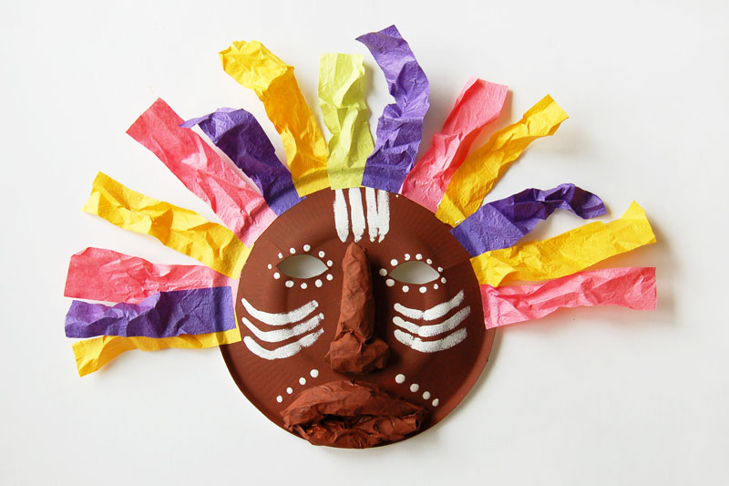
- Virtual Explorer - What are the continents of the world? Where are they located? What languages are spoken in these continents? Ask your child to use Google Maps to explore a continent of their choice. Can they create a continent fact file or choose a particular country they are interested in and create an information guide including the weather, tourist locations, landmarks, weather, traditional music, food, flags. Remember to tweet a photo of their fact file or information guide #TheLearningProjects.

- Mask Making - Ask your child to use paper or cardboard and a range of materials around the home to design and create their own African mask. Can they find out their importance to African culture by watching this clip?

- Dance Around the World - Use SafeYoutube to dance along to some different cultural dances from around the world, such as the Brazilian Samba, the traditional Diwali stick dance or the Spanish Flamenco. Your child can design a cultural costume for their favourite dance and label it with suitable materials. Why not record a video to share with your school’s Twitter? Encourage your child to watch the recording back and evaluate their dance. Recommendation at least 2 hours of exercise a week.

- Speak the Language - Encourage your child to discuss with their family the links they and their family have to the wider world. Find out places family members have visited on holiday, work/business links or simply countries they would like to visit in the future. Have a go at learning some simple phrases in different languages from around the world and write the phrases using the colours of the flag for that country. You could visit the Mrs Mandarin website here.

- Tribal Traditions - Ask your child to find out about the cultural differences, customs and traditions of an indiginous group/tribe from around the world such as the Maori people, Native Americans, the Yanomami tribe or the African Maasai tribe. Ask your child, why it is important indigious people are remembered? Can your child create some artwork inspired by one of the tribes?
STEM Learning Opportunities #sciencefromhome
Engineering Around the World – World’s Tallest Tower
- In 2020 the new world’s largest tower will be the Jeddah Tower, in Saudi Arabia. It will have 200 floors and will the reach 1008 meters high.
- Use scrap paper and junk box materials to build a tower. You might like to search for photos of the ‘Jeddah Tower’ to help you with your design.
- What is the tallest tower you can build?
Additional learning resources parents may wish to engage with
- BBC Bitesize - Lots of videos and learning opportunities for all subjects.
- Classroom Secrets Learning Packs - Reading, writing and maths activities for different ages.
- Twinkl - Click on the link and sign up using your email address and creating a password. Use the offer code UKTWINKLHELPS.
- White Rose Maths online maths lessons. Watch a lesson video and complete the worksheet (can be downloaded and completed digitally).
- Times Table Rockstars and Numbots. Your child can access both of these programmes with their school logins. On Times Table Rockstars, children should aim to play Soundcheck for 20 minutes daily.
- IXL online. Click here for Year 3 or here for Year 4. There are interactive games to play and guides for parents.
- Mastery Mathematics Learning Packs. Take a look at the mastery mathematics home learning packs with a range of different activities and lessons.
- Y3 Talk for Writing Home-school Booklets and Y4 are an excellent resource to support your child’s speaking and listening, reading and writing skills.

