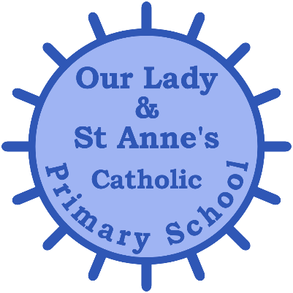
TERM DATES FOR ACADEMIC YEAR 2021-2022

AUTUMN TERM 2021
School Opens : Wednesday 8th September 2021

School Closes for Half Term : Friday 22nd October 2021

School Opens : Monday 1st November 2021

School Closes for Christmas : Friday 17th December 2021

SPRING TERM 2022
School Opens : Wednesday 5th January 2022

School Closes for Half Term : Friday 18th February 2022

School Opens : Monday 28th February 2022

School Closes for Easter: Friday 8th April 2022

SUMMER TERM 2022
School Opens : Monday 25th April 2022

School Closes for Half Term : Friday 27th May 2022

School Opens : Monday 6th June 2022

School Closes for Summer : Friday 22nd July 2022

Staff Training Days
School governors are required to identify 3 days as staff training days. They have determined Monday 6th September 2021, Tuesday 7th September 2021 and Tuesday 4th January to be training days.
May Bank Holiday – School Closed Monday 2nd May 2022.
Queens Jubilee Bank Holiday – School Closed Monday 6th June 2022

