KS2 Mini Art Challenge
Draw the images on the list in a miniature style! Each one must be no more than 5cm x 5cm. Are you up for the challenge?
Use any materials you like to draw/create the images. You may want to use writing pens, felt tips, pencils, paint, pastels, collage or wax crayons. Maybe you have another idea you would like to try!
You can present your pictures however you like! You may want them all on one page, in a book, hooked on a keyring, stapled together - it really is up to you!
A reflection  A view through a window  A plant or flower  A mythical creature  A smooth object  A road  Your favourite food  Something yellow  An interesting building  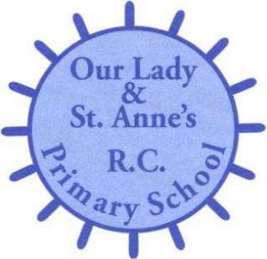  An insect  A strange animal |  | A treasure map  A vehicle  An interesting bird  Your front door  Your hand  Your eye  A mouth  A shoe  A piece of fruit  Your initials in an interesting  font  An empty space
Try to add as much detail as you can.
While drawing think about…
… the colours you choose
… how you are using line
… the tints, tones and shades you are creating
