Our Lady & St Anne’s RC Primary School

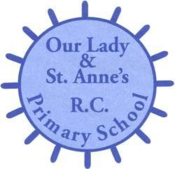
Appointment of Chargehand Cleaner: Level N3

Salary £18,065 - £18,426 (actual £9.765 - £9,960) per annum
Part Time (20 hrs per week, 2pm – 6pm Mon-Fri)
(Additional hours will be required to cover any periods of absence of Facility
Manager)
Permanent Contract

Required for Immediate Appointment

The Governors are seeking to appoint a suitably qualified enthusiastic and well motivated chargehand cleaner to join our team.

We are looking for someone who:

- Supports the Catholic ethos of our school
- Is extremely organised
- Has high expectations
- Works as part of a team to achieve very high standards
- Has a good sense of humour!

The Governing Body is strongly committed to safeguarding and promoting the welfare of children and young people. The post is subject to an Enhanced Certificate of Disclosure from the Disclosure and Barring Service and a range of other recruitment checks.

Application forms and further details are available on the school website only. www.olsa.org.uk.

Completed applications are to be returned by post to the School Business
Manager at the above address or can be emailed to ourladyadmin@olsa.org.uk

Closing Date: 22nd November 2019
Shortlisting: Monday 25th November 2019
Interviews: W/C Monday ^{2nd} December 2019

